**Week 2**

**Applying and Preparing to Interview**

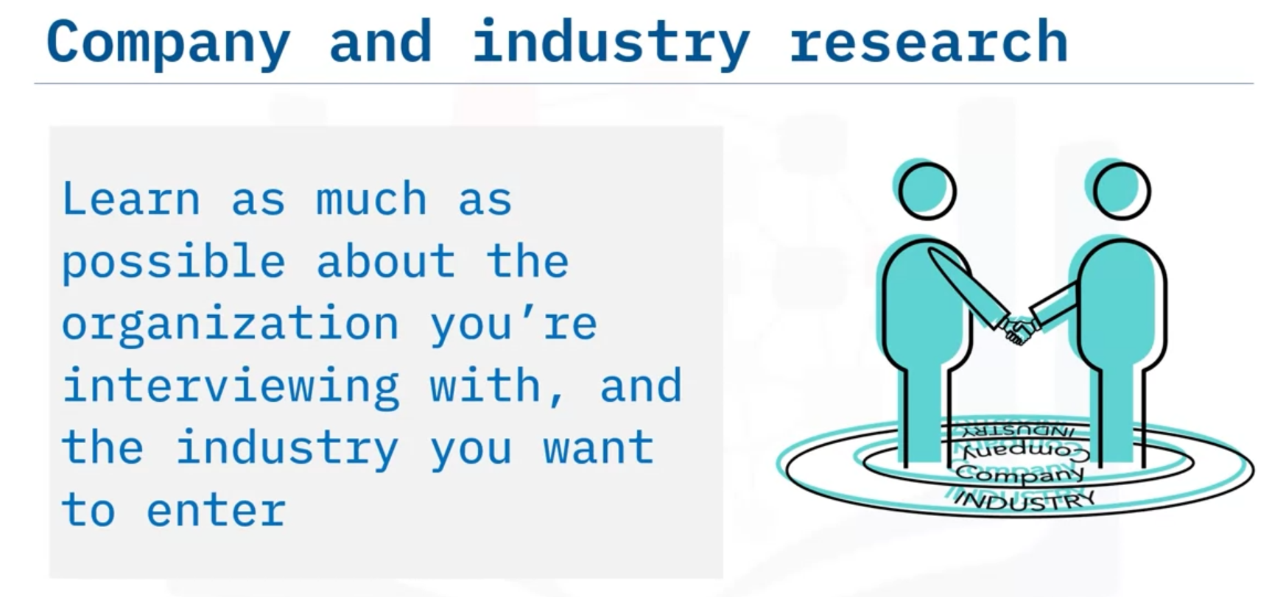

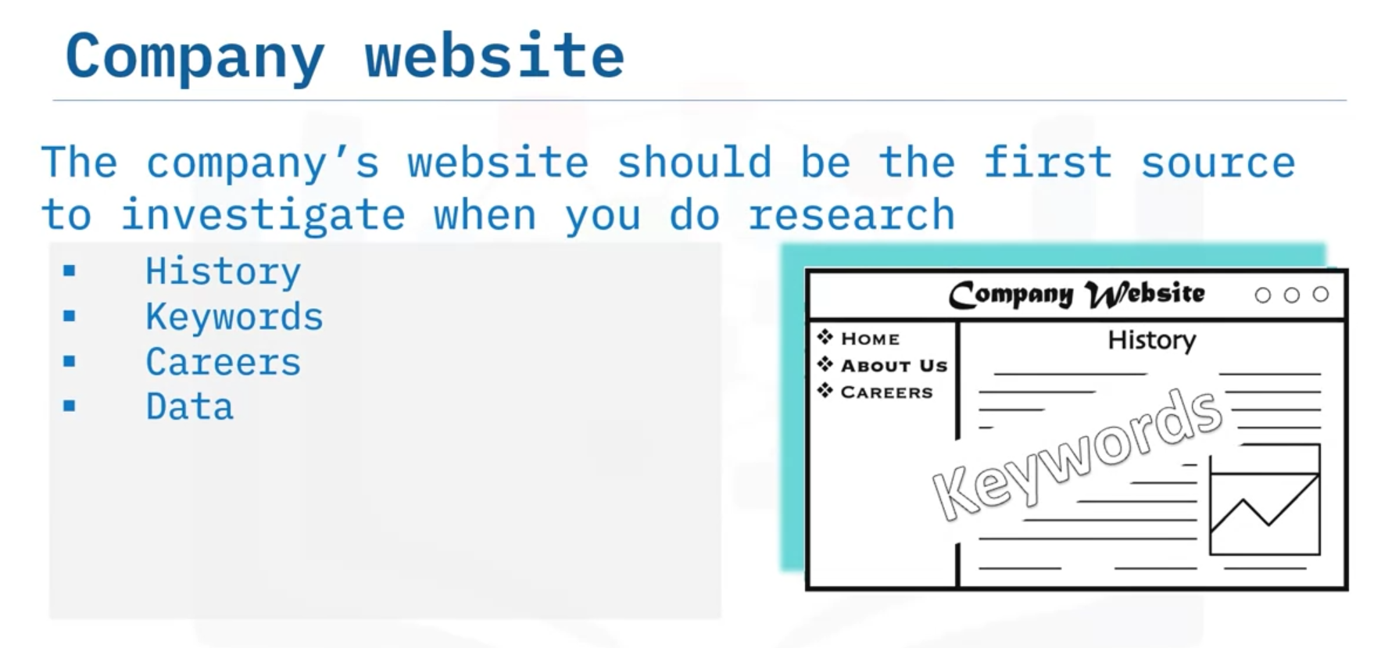

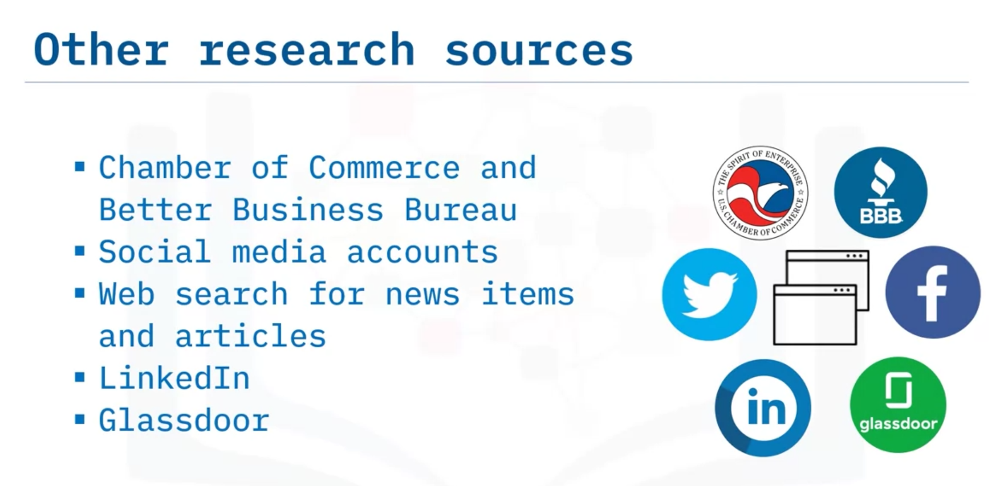

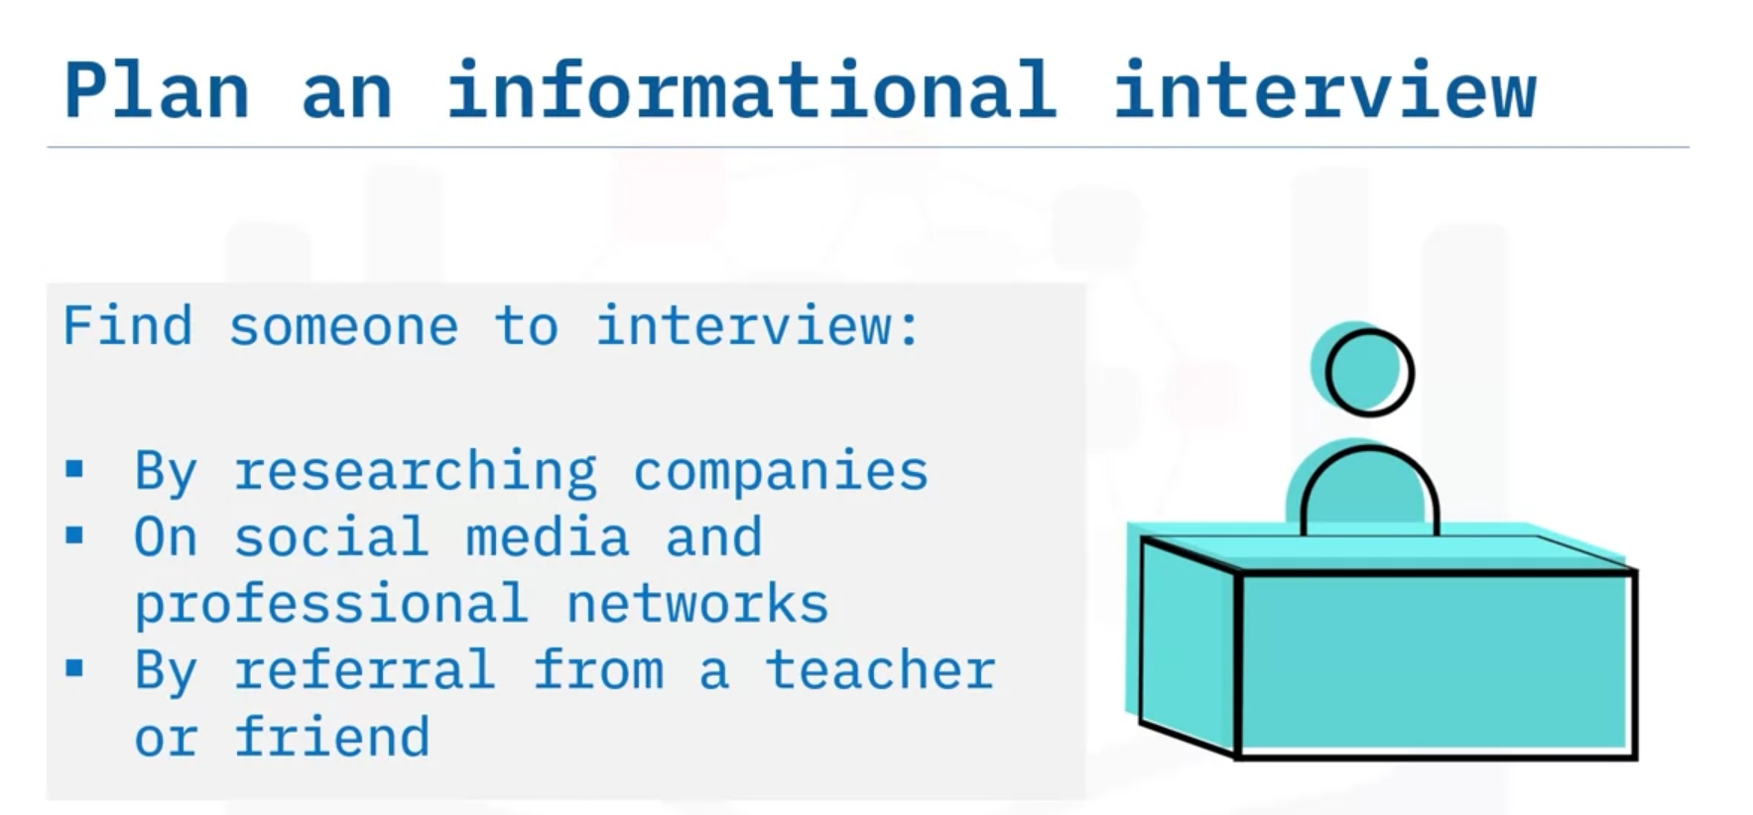

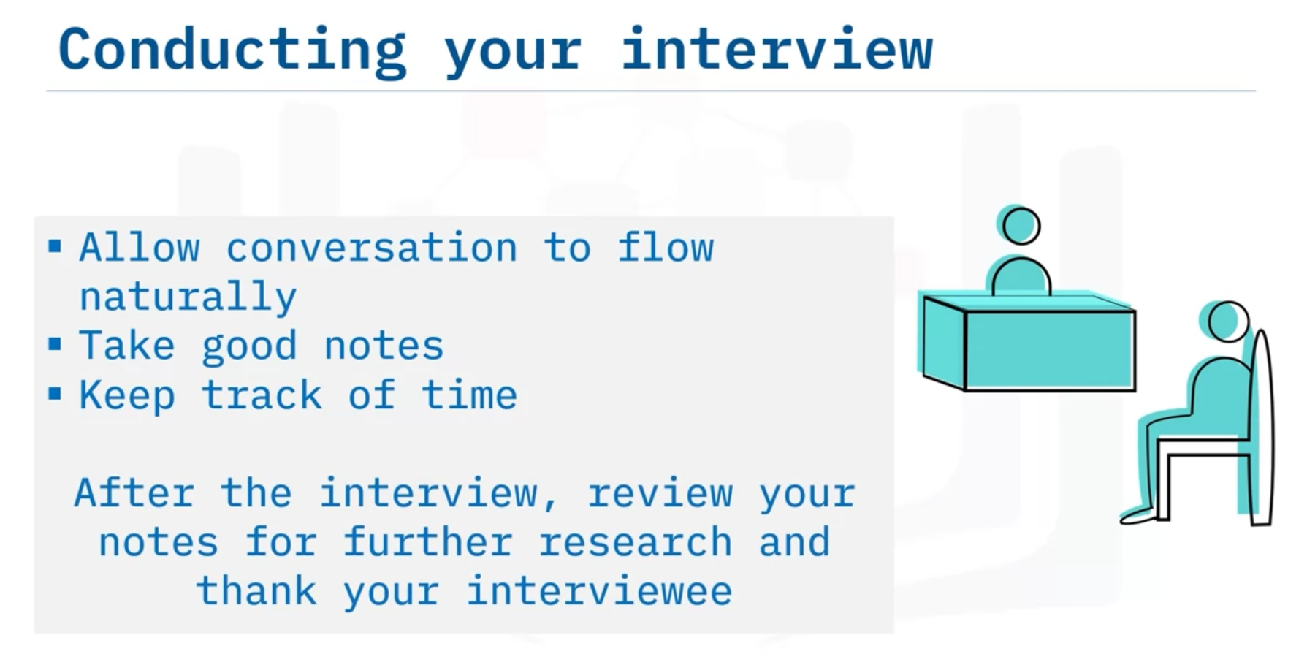

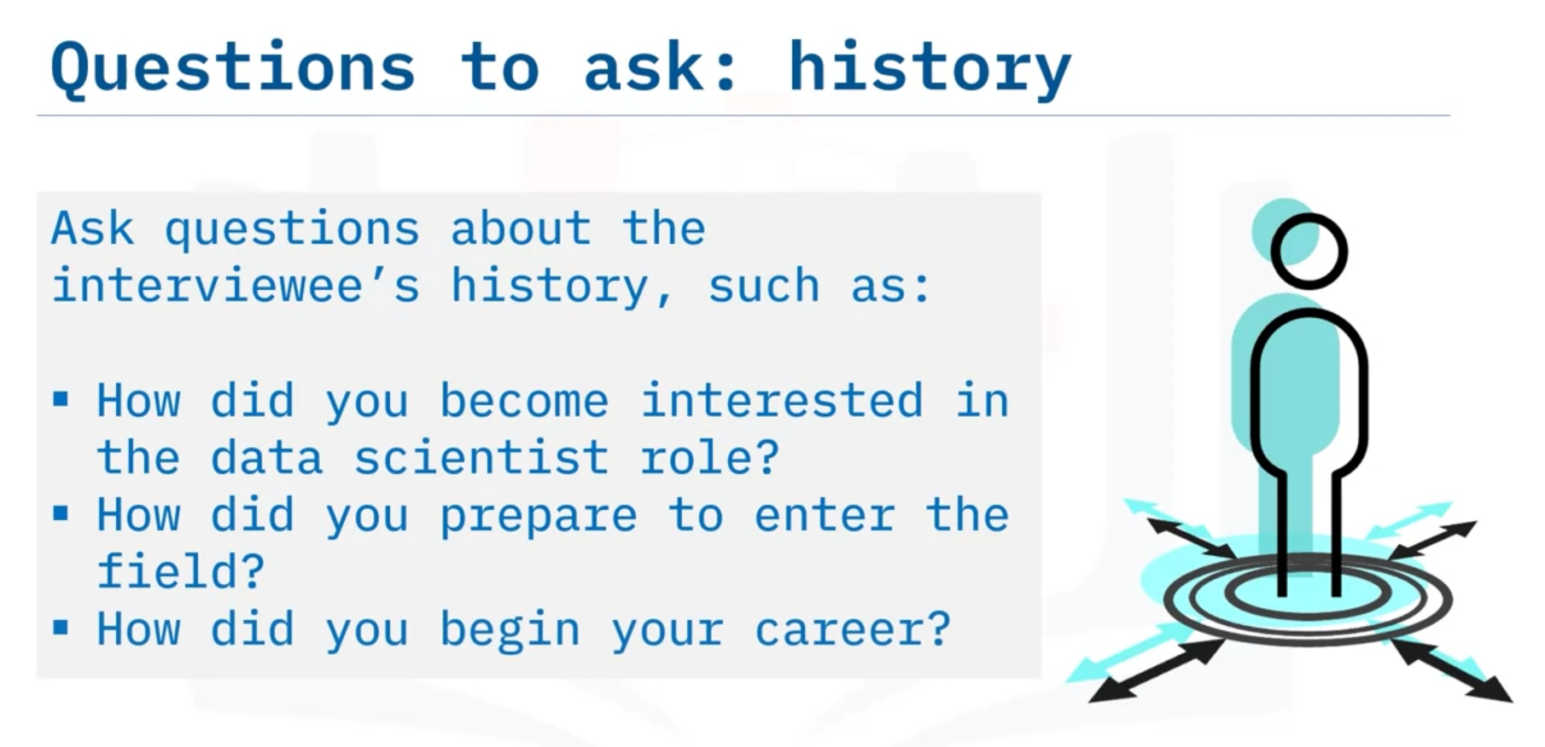

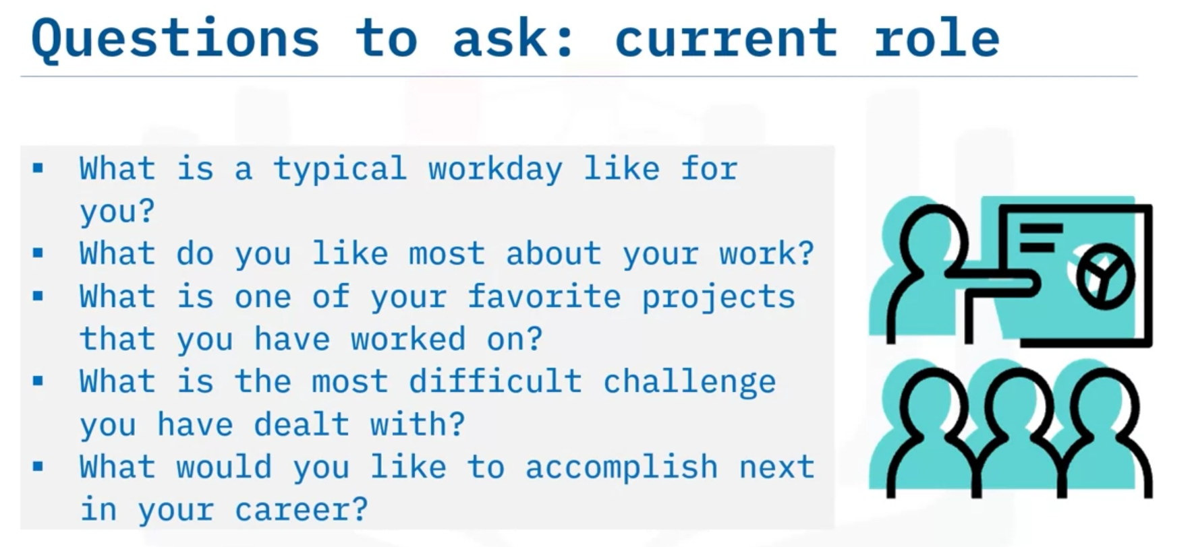

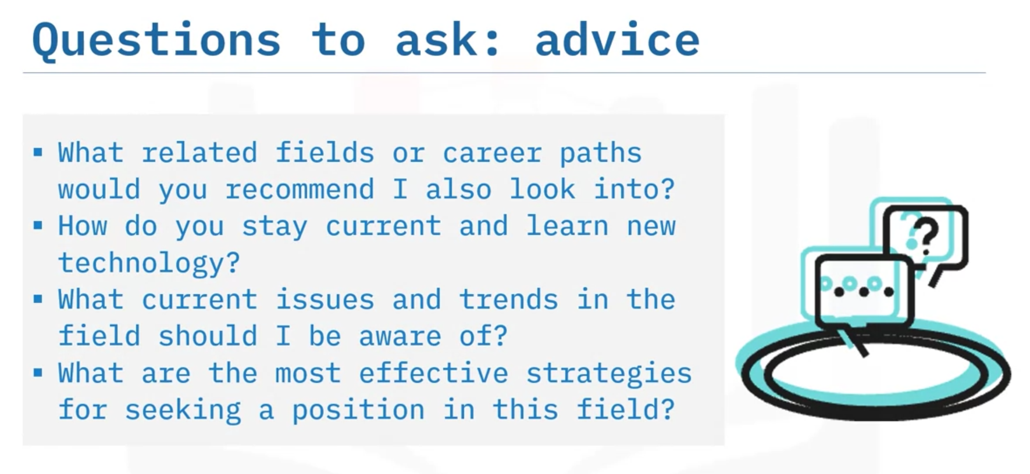

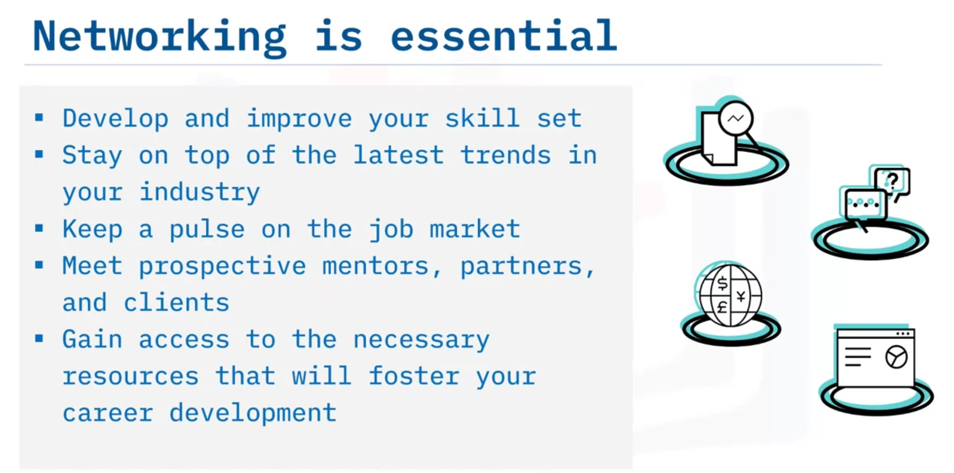

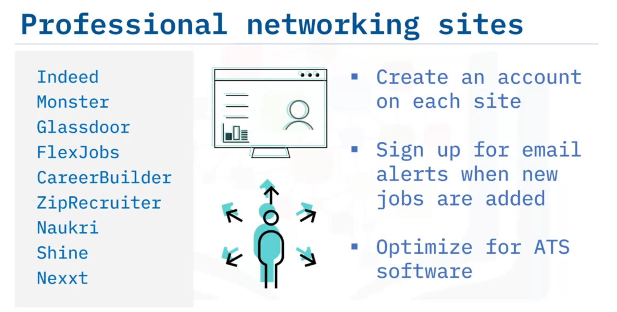

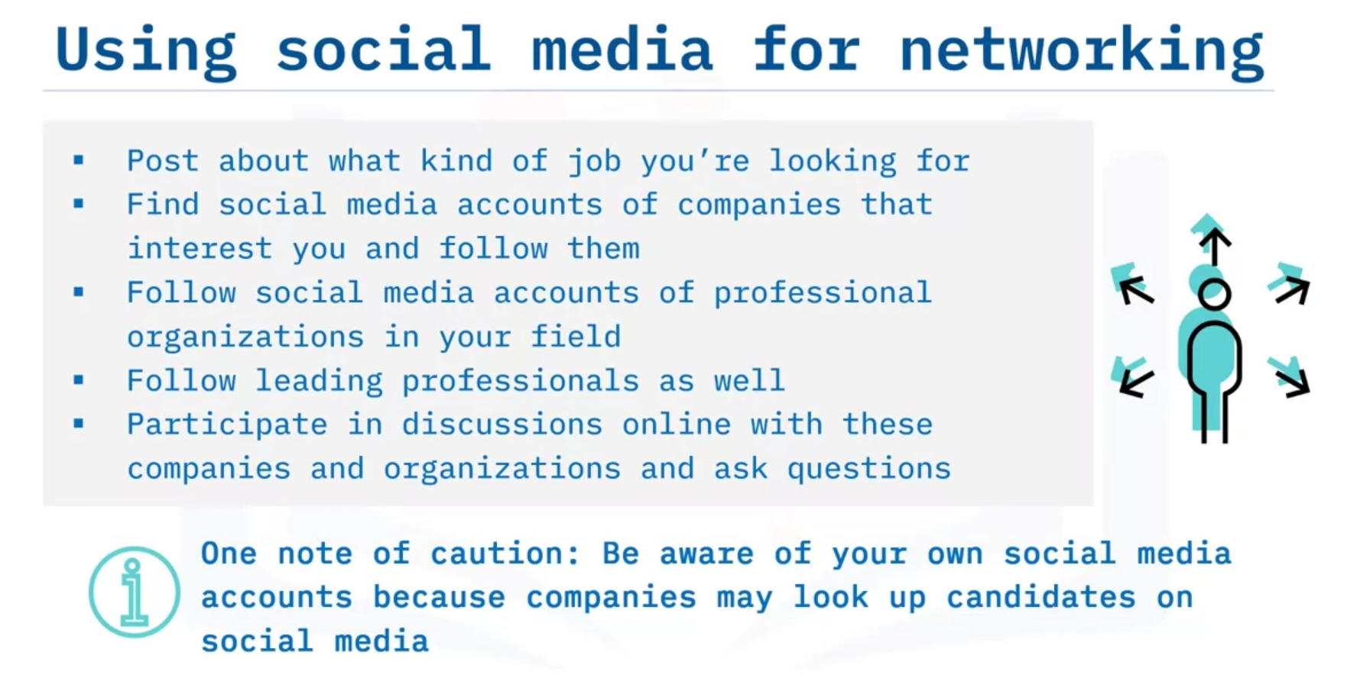

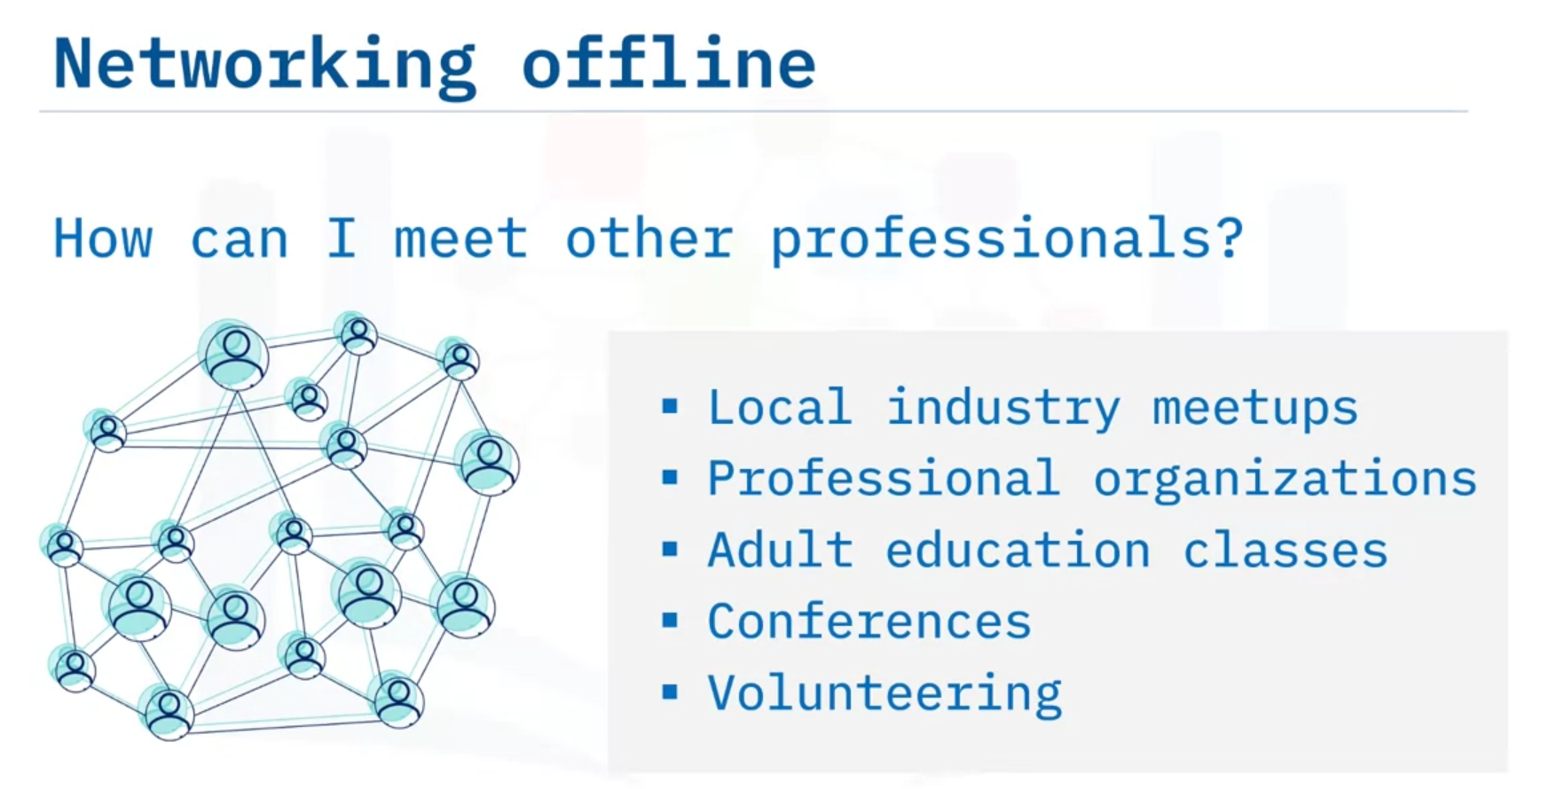

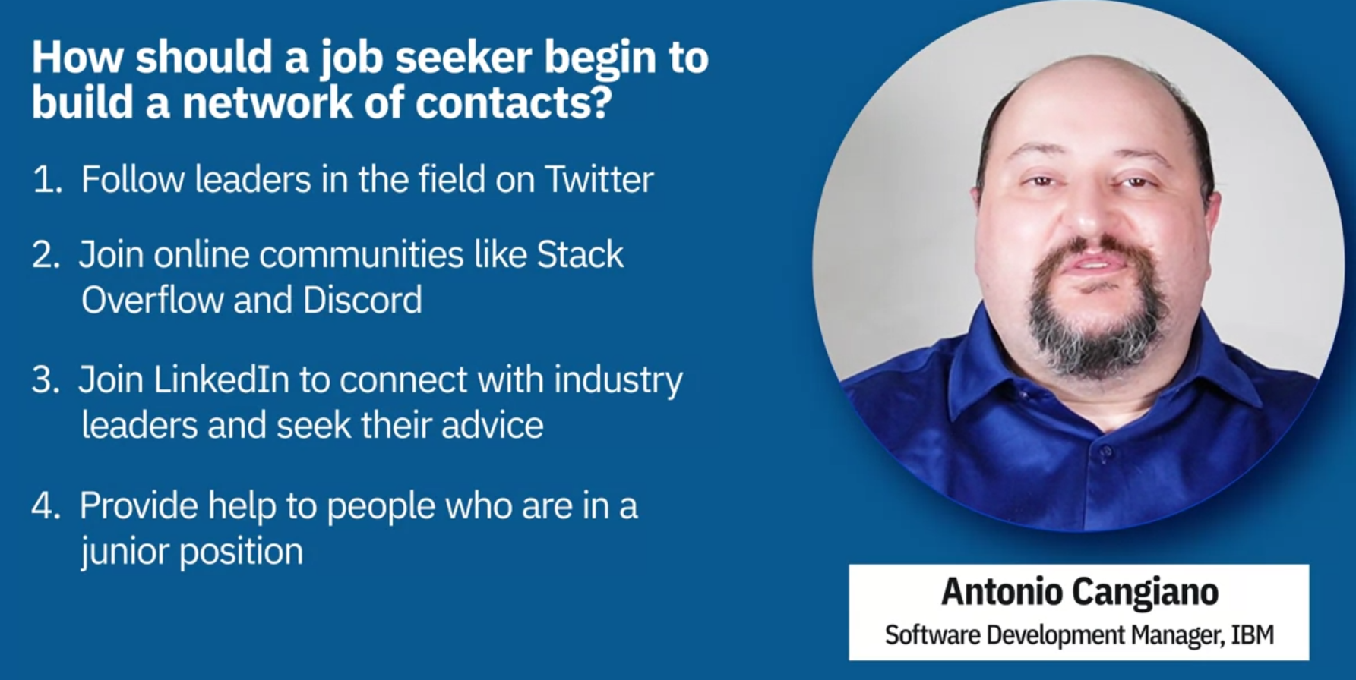

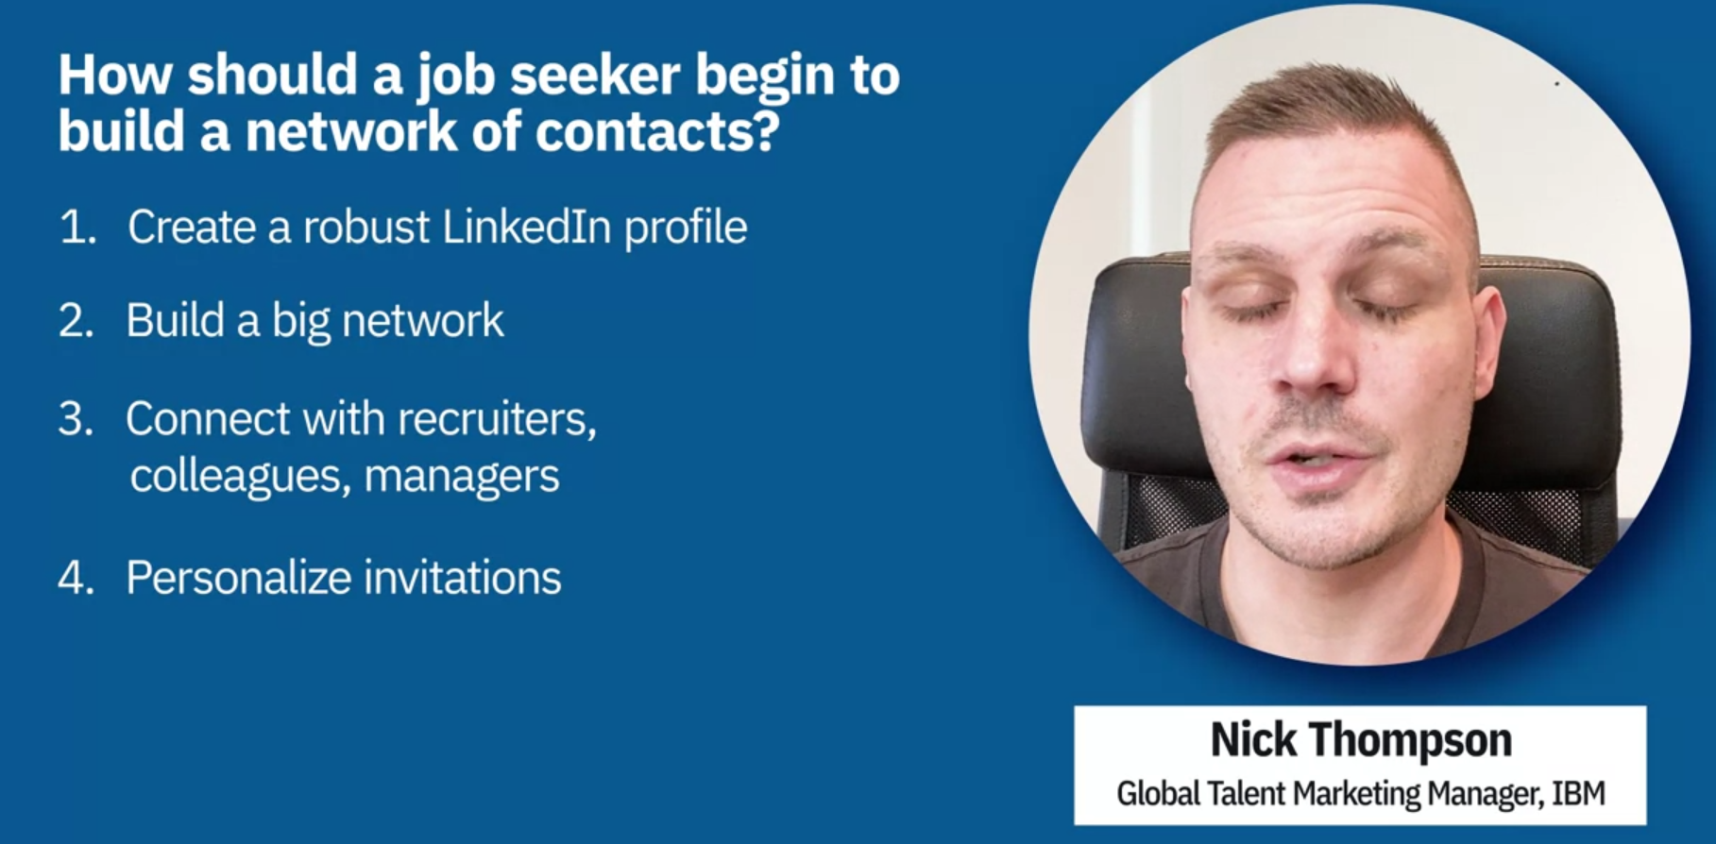

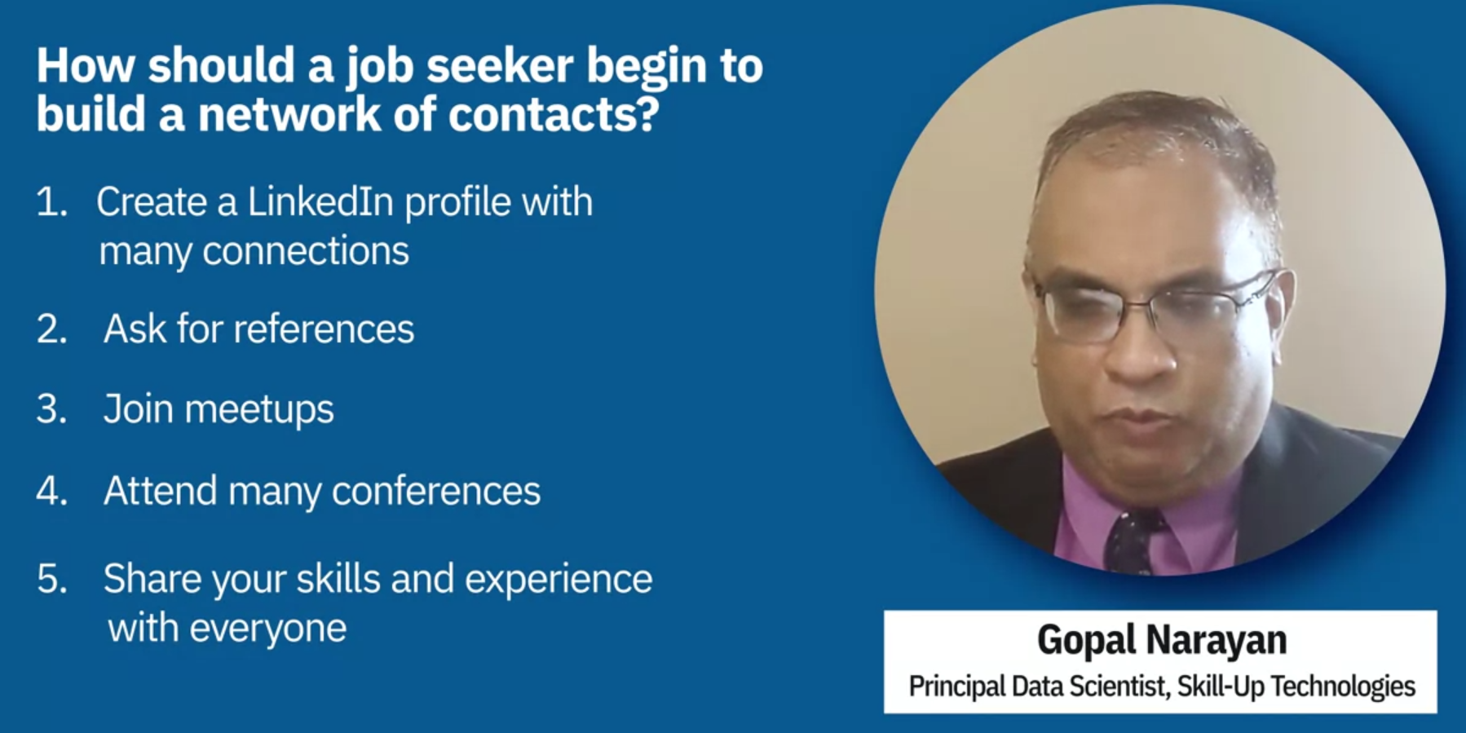

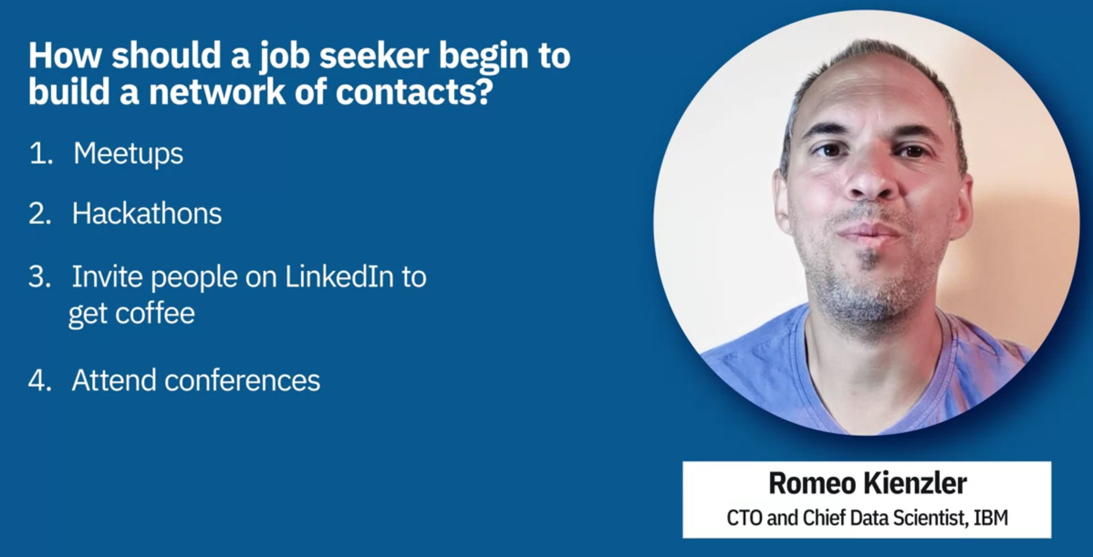

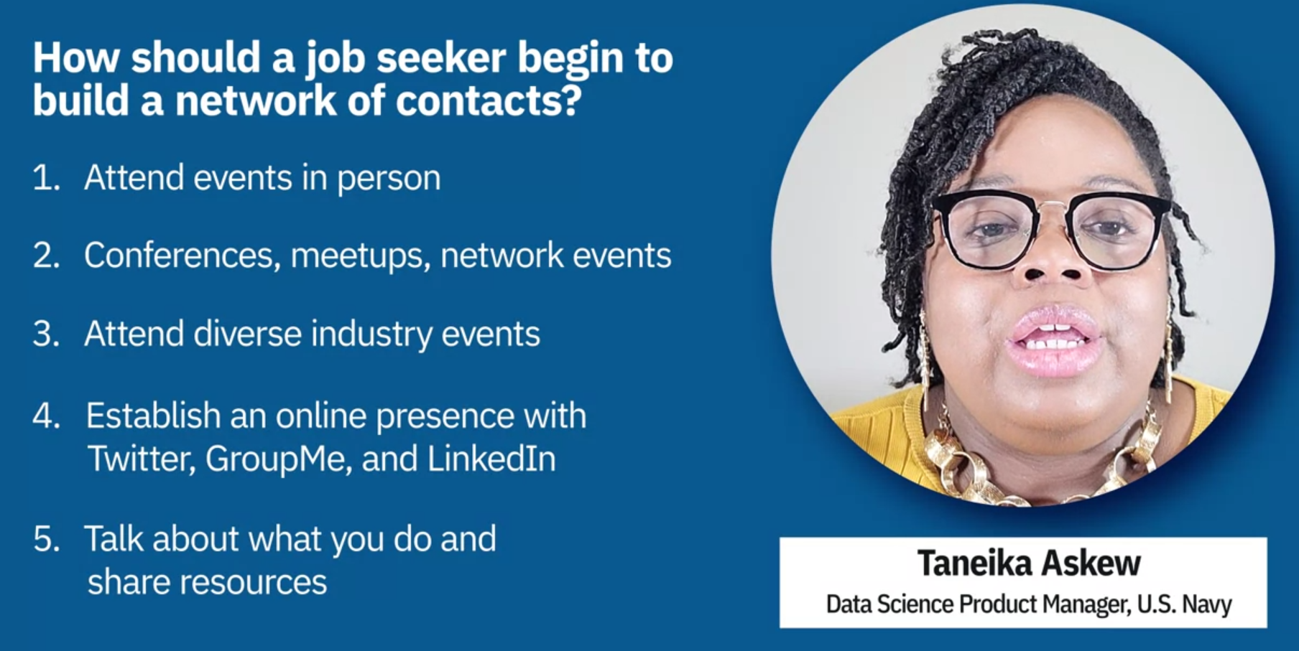

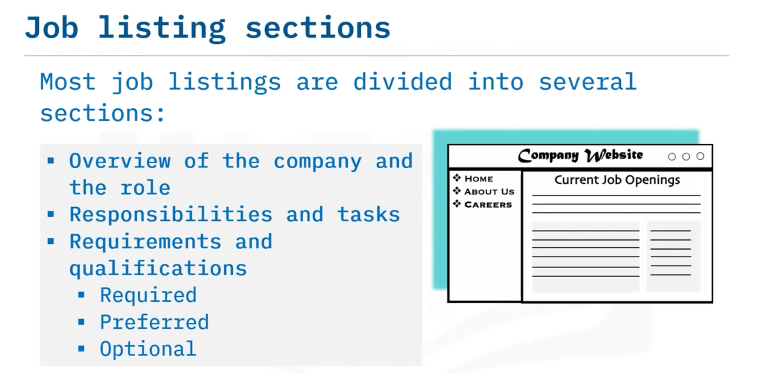

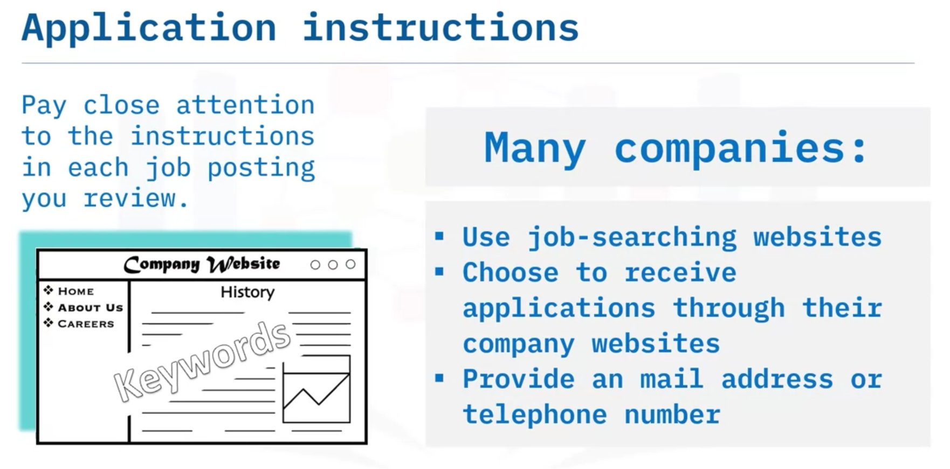

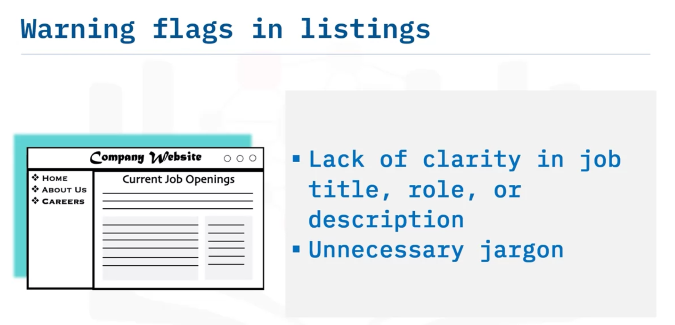

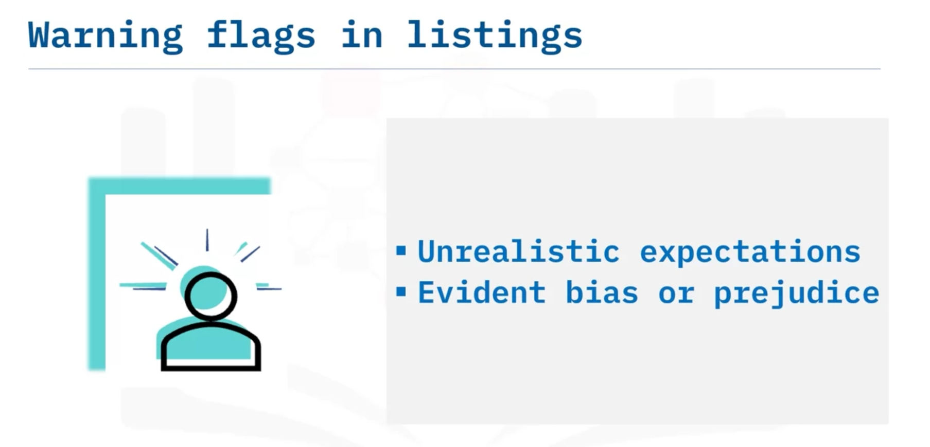

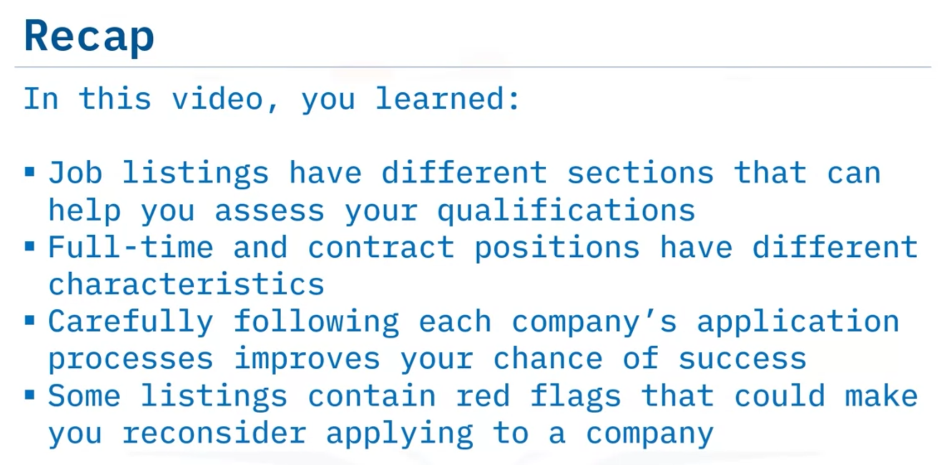

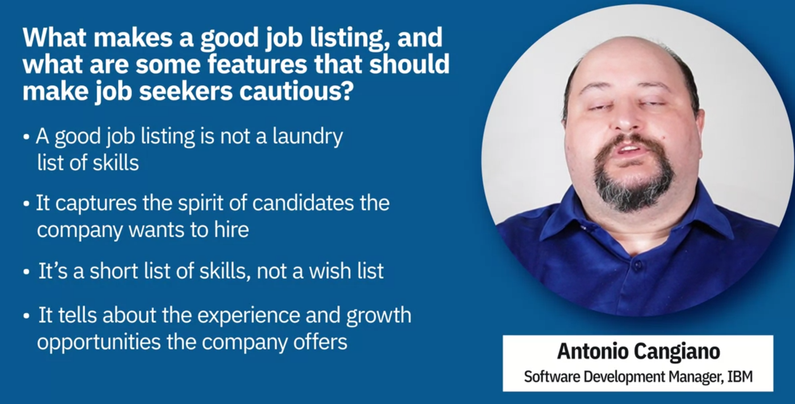

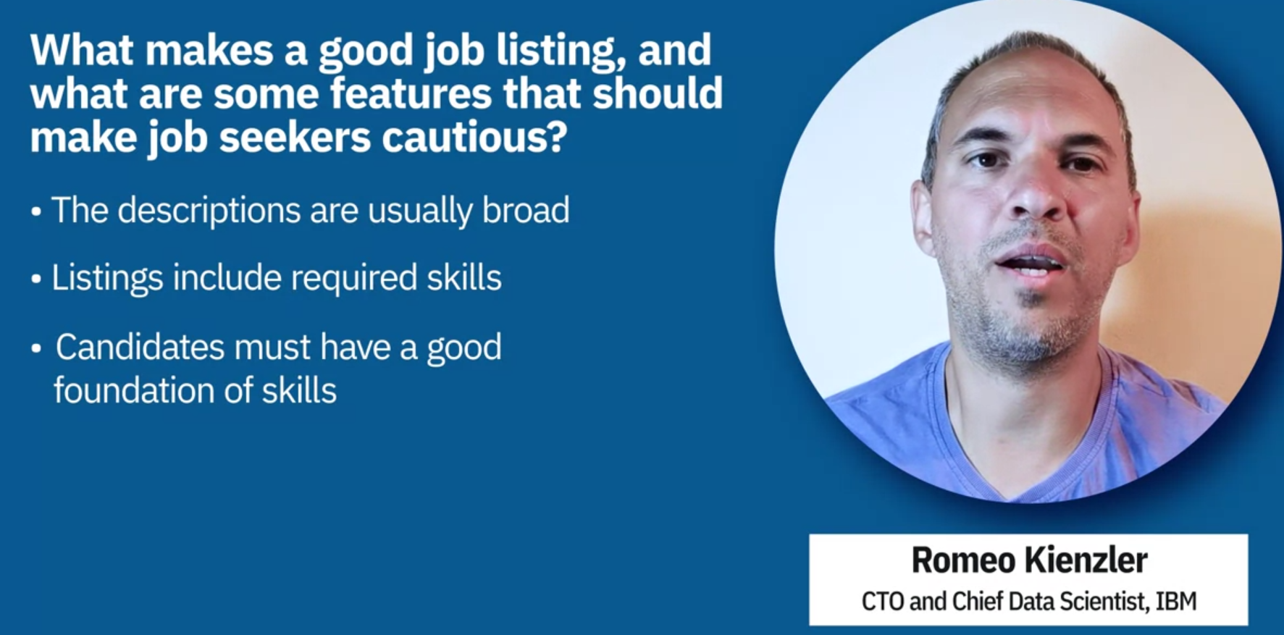

For example, if you know, I don't know, in Apache Spark SQL you can easily learn, HBase or Hive or, or Impala or something. Same, if you have experience in TensorFlow, it's usually not a big deal to learn PyTorch then.

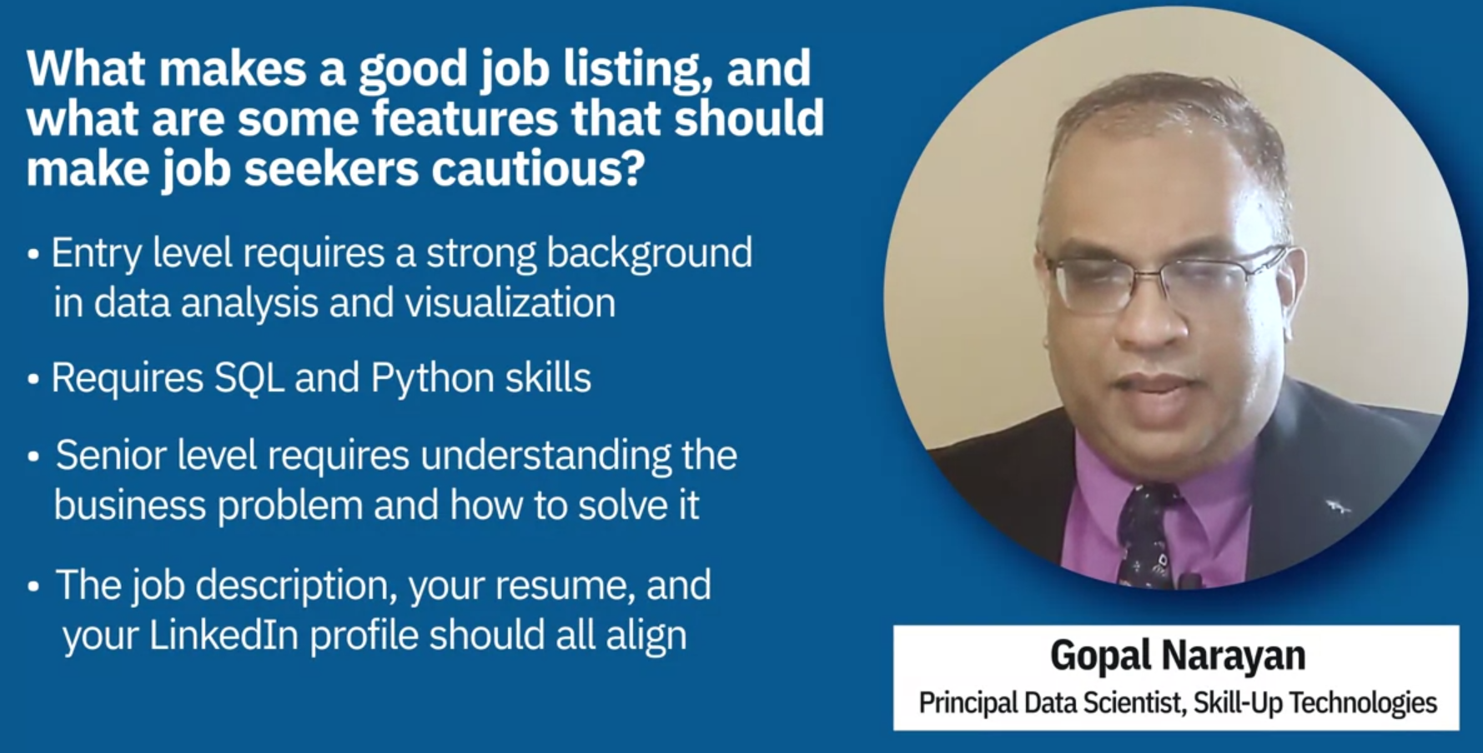

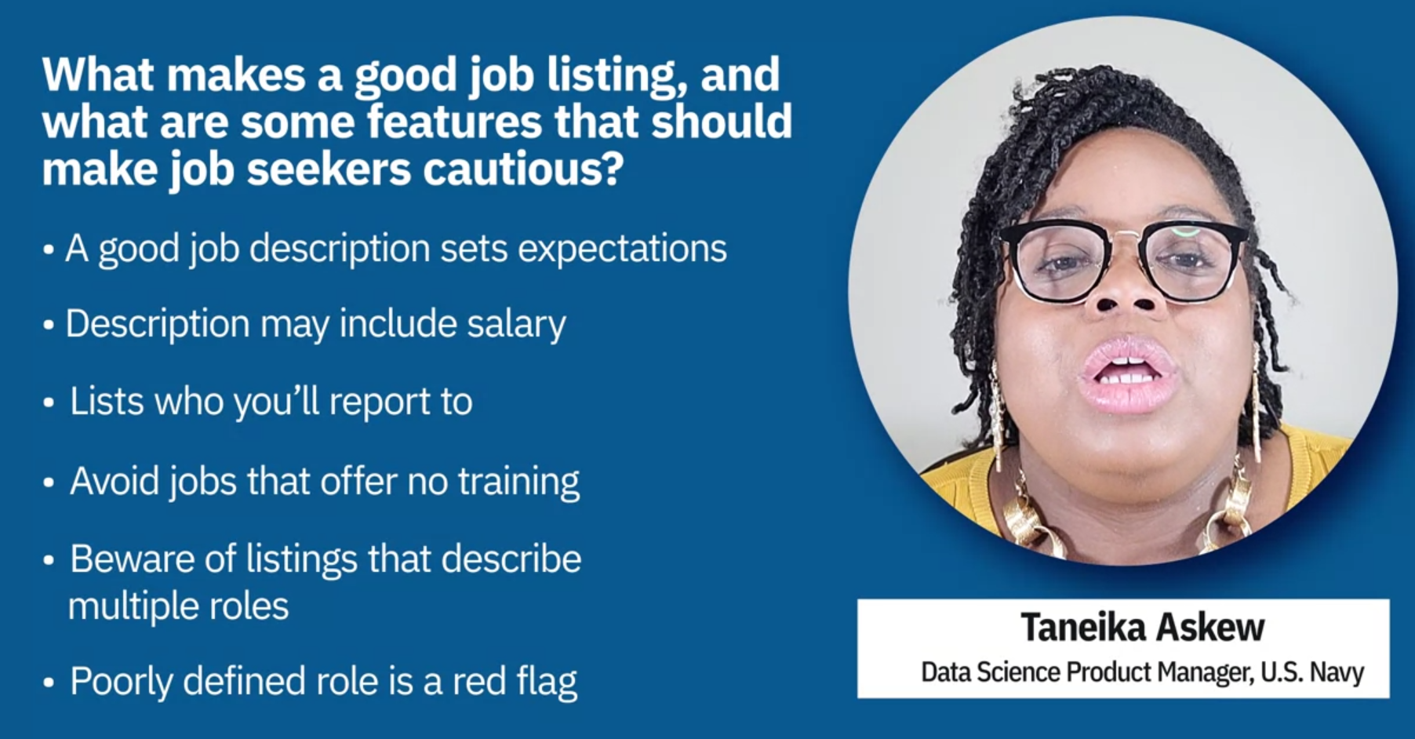

# Applying for a Job

When you’ve found a job listing for a role that interests you and for which you are well qualified, it’s time to consider how to apply for the job. Navigating a company’s application process can be tricky, however, and each company has its own procedures. If you read carefully and consider your application materials thoughtfully, you can make an application that stands out.

First of all, read the listing to see whether the company prefers you to fill out an online application, use a website application process (such as on LinkedIn), send a resume and cover letter to an email address, or some other procedure. Follow the directions very carefully and do exactly as they say. If you don’t, your application may be disqualified and never seen by the company’s hiring managers.

There is usually no limit to the number of applications an aspiring job candidate can submit, especially if the job search targets different companies. However, some companies limit the number of applications you can send in a particular period, so you’ll need to be strategic and choose the jobs that are the most interesting to you.

There may be other strategic considerations. When you are interested in multiple positions within a company, whether it’s better to focus on one application or apply for multiple open positions can depend on several factors. One approach would be to apply first for the position you believe you are most qualified for or that interests you most. After applying, contact human resources (HR) or a hiring manager to ask for advice about whether you should apply for each job you are interested in or if it’s best to avoid duplicate application submissions. They should be able to tell you whether they can forward your application or whether they allow you to create a profile that lets you easily apply for multiple jobs.

## Resume and cover letter

In almost every case, you’ll need to send a resume, and in most cases, you should send a cover letter, even if it isn’t required. If you’ve already drafted basic versions of these two documents, you’re in a good position. You will need to edit them to fit each job, but you won’t need to start from scratch. Work carefully and make sure you include information that shows your skills and experience to advantage for each specific role.

* **Resume** – Double-check for these potential problems and any others you may spot:
  + Outdated or missing contact information
  + Grammatical and formatting errors
  + Using an unprofessional email address
  + Cliche vocabulary or jargon
  + Unrelated job experience or irrelevant hobbies
  + Attaching a photo of yourself (your resume should not contain a photo)
* **Cover letter** – Be careful to check for these issues:
  + Grammatical and formatting errors
  + Too long (multiple pages) or too brief
  + Addressing the wrong person or misspelling a name
  + Not tailoring the letter to the specific company and job opening
  + Tone is arrogant or too humble—try for a professional, confident tone
  + Listing references in the letter
  + Explaining the reason(s) why you are no longer working for your previous employer or including other issues that may be better to discuss in an interview if necessary

## Other application documents

In addition to a copy of your resume and cover letter, a potential employer may request other documents to validate your qualifications such as educational transcripts, writing samples, portfolios, certifications, a list of references, and letters of recommendation. Supporting documentation will vary among hiring companies and job positions. Be sure to follow all the instructions provided by the company to avoid submitting an incomplete job application.

## Document naming and organization

Before uploading a PDF or other formatted files, make sure that you have used a consistent naming convention for your files. Include your full name as part of the file names. For example, if your resume is contained in an electronic file with the name “John_Smith-Resume.pdf,” then name the rest of your supporting documents similarly (“John_Smith-Cover_Letter.pdf”). In short, name your files consistently and in a way that, if sorted alphabetically, all your files will appear together in a file search. This helps the recruiter identify all the files that you submitted. For example:

|  |  |  |  |
| --- | --- | --- | --- |
| Name | Date modified | Size | Kind |
| Red pdf icon - Free red file iconsJohn_Smith-Cover_Letter.pdf | April 4, 2022 at 2:20 PM | 302 KB | PDF Document |
| Red pdf icon - Free red file iconsJohn_Smith-References.pdf | March 14, 2022 at 2:44 PM | 45 KB | PDF Document |
| Red pdf icon - Free red file iconsJohn_Smith-Resume.pdf | May 12, 2022 at 8:01 AM | 224 KB | PDF Document |
| Red pdf icon - Free red file iconsJohn_Smith-Transcripts.pdf | May 3, 2022 at 3:02 PM | 362 KB | PDF Document |

Limit your special characters to underscores and/or hyphens. If you incorporate blank spaces in your file names, be sure to use them consistently. Do not include version numbers as part of your file names and be sure to submit all the requested documents at once.

It may be convenient to create a template for your cover letters. Include your name, job title, and contact information. Use a cover letter you have already written and identify the customized information. Highlight it to ease the process of tailoring a subsequent letter for a different position title or company. Save the template letter with the word “template” included in its name and use it as needed. Once a new tailored letter is written and ready, save the file, replacing the word “template” with the company’s name or the job title you are applying for.

## LinkedIn profile

For a modern job seeker, using the job search site LinkedIn is imperative. An overwhelming percentage of recruiters and other hiring professionals use the site to find candidates, so no potential candidate can afford to skip it. You can seek job listings, make applications, network, post your information, boost your visibility, and more.

Make sure that your LinkedIn profile is complete and matches the information on your resume and other materials. Take the time to list your skills thoroughly to improve your chance of appearing in searches. Ask colleagues to add endorsements as well.

Some other tips to get the most out of LinkedIn include:

* Keeping track of job applications via the Jobs homepage. See which jobs you applied for, when you applied, and whether your application has been reviewed.
* Uploading cover letters and attaching them to resumes when you apply for positions. Cover letters get scanned too, which also improves your chances of being seen.
* Following companies where you are applying and prominent professionals in your field. Recruiters can see this, and you may get useful information as well.

## Conclusion

Your application for a job is the first impression a company will have of you as a candidate, so make sure it’s effective. Always follow the company’s instructions and take the opportunity to provide information about your qualifications and career aspirations. Correctness and accuracy in all your supporting documents complete the image you project and will help you stand out from the competition. With luck, your work here will compel recruiters to learn more about your skills and experience and see if your goals align with the company’s mission and goals.